Code Alpha
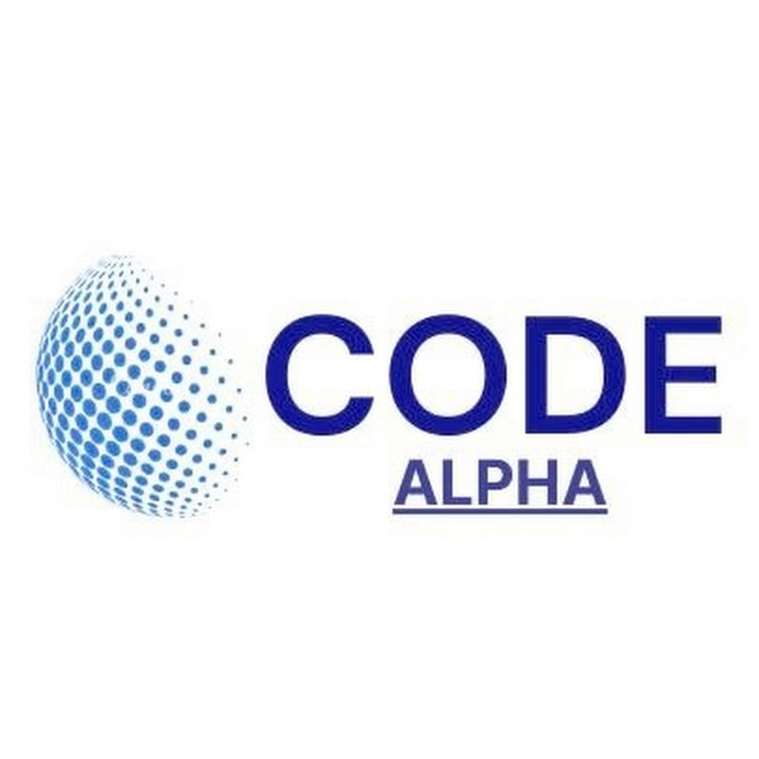

Case Study on Code Alpha Intern Success

Prepared by – Nikunj Pant

Summary
This case study highlights the journey of Rahul Sharma, a hypothetical Computer Science student who enhanced his career prospects through a virtual internship at Code Alpha. Before joining the internship, Rahul faced challenges such as limited practical experience, lack of industry exposure, and low confidence in technical interviews.
During the internship, he worked on real-world coding projects, learned industry-standard tools like Git and GitHub, and improved both his technical and professional skills. The project-based learning approach helped him develop expertise in web development, programming, debugging, teamwork, and communication.
By completing multiple projects and building a strong portfolio, Rahul became more confident and employable. His Code Alpha internship experience strengthened his resume and helped him secure a Junior Software Developer position. The case study demonstrates how Code Alpha's internship programs support student growth through hands-on learning, mentorship, and practical exposure, ultimately preparing them for successful careers in the technology industry.

Table of Contents
- Introduction
- Background
- Challenges Faced
- Internship Experience at Code Alpha
- Skills Developed
  - 5.1 Technical Skills
  - 5.2 Professional Skills
- Career Growth and Employability
- Impact of Code Alpha
- Conclusion

Introduction
Internships play a crucial role in helping students bridge the gap between academic learning and professional experience. In today's competitive job market, employers seek candidates who possess both technical knowledge and practical skills. Platforms like Code Alpha provide valuable opportunities for students to gain hands-on experience through project-based internships. This case study highlights how a student benefited from a Code Alpha internship and improved their career prospects through skill development, practical exposure, and professional growth.

Background
Rahul Sharma (hypothetical student), a third-year Computer Science student, was passionate about programming but lacked real-world experience. Although he had learned programming languages such as Python, Java, and HTML through his coursework, he struggled to apply his knowledge to practical projects. His resume contained only academic assignments, and he lacked confidence when applying for internships and entry-level positions.
Recognizing the need for industry exposure, Rahul searched for opportunities that would help him strengthen his technical skills and build a professional portfolio. He decided to enroll in a virtual internship program offered by Code Alpha.

Challenges Faced
Before joining Code Alpha, Rahul encountered several challenges:
- Limited practical coding experience.
- Lack of real-world projects for his portfolio.
- Difficulty understanding industry workflows.
- Low confidence during technical interviews.
- Limited knowledge of collaborative development tools such as Git and GitHub.
These challenges made it difficult for him to compete with candidates who already possessed internship experience.

Internship Experience at Code Alpha
During his internship at Code Alpha, Rahul was assigned multiple project-based tasks designed to simulate real-world development environments. The internship emphasized hands-on learning rather than theoretical instruction.
His primary project involved developing a web-based application using HTML, CSS, JavaScript, and Python. Throughout the internship, he learned how to:
- Design user-friendly interfaces.
- Write clean and maintainable code.
- Debug and test applications.
- Use GitHub for version control.
- Document project requirements and outcomes.
- Collaborate in a professional development workflow.
Code Alpha's structured learning environment encouraged Rahul to solve practical problems independently while receiving guidance and feedback from mentors. This approach significantly improved his technical understanding and problem-solving abilities.

Skills Developed
By the end of the internship, Rahul had acquired several valuable skills:

Technical Skills
- Web Development
- Python Programming
- Front-End Design
- Version Control using Git and GitHub
- Software Testing and Debugging

Professional Skills
- Communication and Reporting
- Time Management
- Team Collaboration
- Critical Thinking
- Project Documentation
These skills helped him become more industry-ready and increased his confidence in handling technical tasks.

Career Growth and Employability
One of the most significant outcomes of Rahul's internship was the development of a professional portfolio. He successfully completed multiple projects that highlighted his abilities and demonstrated practical experience beyond classroom learning.
After completing the internship, Rahul updated his resume and LinkedIn profile with his Code Alpha projects and achievements. During job interviews, he could discuss real-world challenges he had encountered and explain how he solved them.
Employers responded positively to his internship experience because it demonstrated initiative, technical competence, and practical exposure. Within a few months, Rahul secured an interview opportunity with a software development company. His project portfolio and internship experience helped him stand out from other candidates.
Eventually, Rahul received an offer for a Junior Software Developer role, marking a significant milestone in his career journey.

Impact of Code Alpha
Code Alpha played a crucial role in Rahul's professional development by providing:
- Practical project experience.
- Exposure to industry-standard tools and workflows.
- Opportunities to build a professional portfolio.
- Mentorship and constructive feedback.
- Improved confidence and employability.
The internship transformed Rahul from a student with theoretical knowledge into a job-ready candidate capable of contributing to professional software projects.

Conclusion
This case study demonstrates how Code Alpha internships can positively impact student career development. Through hands-on projects, mentorship, and skill-building opportunities, students gain practical experience that enhances employability and professional confidence. Rahul's journey illustrates how virtual internships can bridge the gap between education and industry, helping students develop the technical and professional competencies required in today's job market.
As technology continues to evolve, platforms like Code Alpha will remain valuable in preparing students for successful careers by providing meaningful learning experiences and real-world exposure.

